1.0 | GENERAL
1.1 | Description
 | .1 |  | Work of this Section shall conform to the requirements of the Contract Document.
 | .2 |  | Work Included
 |  |  | i |  |  |  | 2-Hours Fire Rated [Minimum] Proprietary Firestop Compound for Services Penetrations
 |  |  | ii |  |  |  | In order to ensure minimum assurance of product quality, the reference products specified are:
 |  |  |  |  |  |  | a |  |  | CP 670 Firestop Coating
 |  |  |  |  |  |  | b |  |  | CP 643 N/644 Firestop Collars
 |  |  |  |  |  |  | c |  |  | CP 680-P Cast-In Firestop Devices
 |  |  | These proprietary products are available from Hilti (Malaysia) Sdn Bhd, however; tenderers are reminded that they are not obligated whatsoever to obtain the reference products from the above mentioned firm. The tenderers may submit other proprietary made to the Architect for consideration as approved equivalent.
1.3 | SUBMITTALS
 | .1 |  | Submit shop drawings, product data, and manufacturer’s installation instructions for all materials and prefabricated devices, providing descriptions sufficient for identification at the job site.
 | .2 |  | Submit shop drawings showing proposed material, reinforcement’s anchorage, fastenings, and method of installation. Construction details shall accurately reflect actual job conditions.
 | .3 |  | Submit Material Safety Data Sheets with product delivered to job site.
 | .4 |  | Submit complete details of each type of penetration to be used indicating the proper local authority or Uniform Laboratory (U.L.) approved firestop system.
 | .5 |  | To submit 5 years Jointly and Severally Warranty by the Main Contractor, product manufacturer and installer; and Forms C1, C 2 and C3 for Bomba.
1.4 | QUALITY ASSURANCE
 | .1 |  | Firestop system installation shall conform to requirements of qualified designs or manufacturer approved modifications, as supported by engineering reports.
 |  | .2 |  | Install firestop materials, and systems as required under by-laws UBBL 1984 and by these Contract Documents and accepted for use by Director General of Fire Services (D.G.F.S.) or Bomba.
 |  | .3 |  | Submit manufacturer’s product data, letter of certification, or certified laboratory test report that the material or combination of materials (firestop system) meets the requirements specified in accordance with the applicable referenced standards.
 |  | .4 |  | The firestop compound shall not contain any harmful solvents or inorganic fibers. The penetration seal material must be unaffected by moisture and must maintain the integrity of the floor or wall assembly for its rated time period when tested in accordance with D.G.F.S. requirement.
 |  | .5 |  | To prepare and demo the products and application on site for comments by the Architect and other project consultants.
1.5 |  | FIRESTOPPING
 |  | .1 |  | Provide firestop compounds for caulk, pour, wrap, seal, trowel or pump application. Material must be capable of sealing openings around single or multiple pipes against fire, smoke and toxic gases, and maintaining the required fire rating with a thickness no greater than the structure.
 |  | .2 |  | Provide a firestop system consisting of a material, or combination of materials, to retain the integrity of fire-rated construction by maintaining an effective barrier against the spread of flame, smoke or gases through penetrations in fire-rated barriers. It shall be used in specific locations as follow:-
 |  |  |  | i |  | Penetrations for the passage of pipings and ducts through fire-rated vertical barriers (walls and partitions), horizontal barriers (floor slabs and floor / ceiling assemblies), and vertical service shafts.
 |  |  |  | ii |  | Locations where specified in other section of these specifications.
1.6 |  | SUSTAINABILITY: GREEN BUILDING INDEX [GBI]/LEEDS REQUIREMENTS.
 |  | For corporate social responsibility reasons, the Clients intends to develop a sustainable building model by incorporating energy efficient and environment friendly initiatives into the building design and construction. The project team is targeting to a achieve Sustainability Rating in compliance with Non-Residential Non Construction [NRNC] Version 1.0, Green Building Index by Green Building Index Sdn. Bhd./LEEDS. The Green Building Index for NRNC Version 1.0 is included in this document.
 |  | When complete, the building is expected to be one of GBI/LEEDS certified building in Malaysia. All potential contractors and subcontractors involved in the project are required to familarise themselves with the current sustainable initiatives with regards to the built environment as well as with the requirements to the NRNC version 1.0. Whenever requested by the project team [such as GBI/LEEDS Facilitator], the Contractor shall submit related documentation of evidences in complying the GBI/LEEDS requirements.
 |  | The Contractor is required amongst others, to comply with the following:
 |  | .1 |  |  | Enhanced Commissioning of Building Energy System Requirements
 |  |  |  |  | Requirements:
 |  |  |  |  | Liaise with the appointed Commissioning Specialist [CxS] regarding the Commissioning of energy related equipment. To hold meetings whenever requested by client or CxS and to invite related parties such as Sub-Contractors if required. To submit documents and/or drawings to CxS that related to commissioning stage. To follow instructions from CxS in order to follow the standard of commissioning imposed by GBI/LEEDS. To provide necessary training during the commissioning stage to the appointed maintenance team.
 |  | .2 |  |  | Mould Prevention.
 |  |  |  |  | Requirements:
 |  |  |  |  | To control moisture during construction by using normal practices in industry. To liaise and discuss with appointed GBI/LEEDS facilitator and consultants regarding techniques and/or methods of mould prevention during construction.
 |  | .3 |  |  | Building User Manual
 |  |  |  |  | Requirements:
 |  |  |  |  | The Contractor shall submit the Operation and Maintenance manual for all GBI/LEEDS items to the Project Team. The Contractor shall liaise with Sub-Contractor and/or supplier in getting the related documentations.
 |  | .4 |  |  | Formaldehyde Minimisation
 |  |  |  |  | Requirements:
 |  |  |  |  | Reduce the exposure of occupants to formaldehyde and promote good indoor air quality in the living space. Products with no added urea formaldehyde are to be used. All the low Formaldehyde materials specifications shall be endorsed by GBI/LEEDS facilitator before submitting to Client for approval.
 |  | .5 |  |  | Recycle Content Material
 |  |  |  |  | Requirements:
 |  |  |  |  | The Contractor shall use materials with recycled content such that the sum of post-consumer recycled plus one-half of the pre-consumer content constitutes at least 30% [based on cost] of the total value of the materials in the project. Mechanical, electrical and plumbing components shall not be included. Only include materials permanently installed in the project. Recycled content shall be defined in accordance with the International Organisation of Standards Document. The Contractor shall work with subcontractors and suppliers to verify the availability of materials. The Contractor shall propose the materials that have recycle content and to provide evidence from to project team.
 |  | .6 |  |  | Regional Materials.
 |  |  |  |  | Requirements:
 |  |  |  |  | The Contractor shall use building materials or products that have been extracted, harvested or recovered, as well as manufactured, within 500km of the project site for a minimum of 30% [based on cost] of the total material value. The Contractor shall work with subcontractors and suppliers to verify the availability of materials which are extracted/harvested/recovered and manufactured locally. Mechanical, electrical and plumbing components shall not be included. Only include materials permanently installed in the project.
 |  | .7 |  |  | Construction Waste Management.
 |  |  |  |  | Requirements:
 |  |  |  |  | The Contractor shall recycle and/or salvage at least 75% of all non-hazardous construction debris. The Contractor to develop and implement a construction waste management plan that, at a minimum identifies the materials to be diverted from disposal and whether the materials will be sorted on site or co-mingled. The Contractor shall liaise with subcontractors/supplier regarding handling and recording the construction waste. The Contractor shall record and provide evidence regarding the construction waste and all records shall be endorsed by Site Engineer. Quantify by measuring total tonnage of waste.
 |  | .8 |  |  | Storage & Collection of Recyclables
 |  |  |  |  | Requirements:
 |  |  |  |  | During construction, Contractor shall provide a dedicated area where on-site sorted waste materials can be stored in separate skips for collection to recycling facilities. The separate bin shall include metal, wood, crushed concrete and mixed waste. Only non-hazardous construction waste to be included. Hazardous waste, domestic waste, excavation soils and land clearing debris shall have their own designated bins.
2.0 |  | PRODUCTS
2.1 |  | FIRESTOPS
 |  | i |  |  | Firestop compounds shall be provided for caulk, pour, wrap, seal, trowel or pump application. Material must be capable of sealing openings around single or multiple ducts, cables, wire or conduits against fire, smoke and toxic gases, and maintaining rating with a thickness no greater than the structure.
 |  | ii |  |  | The firestop compound shall not contain any harmful solvents or inorganic fibres. The penetration seal material must be unaffected by moisture and must maintain the integrity of the floor or wall assembly for its rated time period when tested in accordance with D.G.F.S. requirement.
 |  | iii |  |  | Firestop system shall consist of a material, or combination of materials, to retain the integrity of fire-rated construction by maintaining an effective barrier against the spread of flame, smoke or gases through penetrations in fire-rated barriers. It shall be used in specific locations as follows:-
 |  |  |  |  | a  b |  |  | Penetration for the passage of duct, cable tray, conduit, and electrical busways and raceways through fire-rated vertical barriers (walls and partitions), horizontal barriers (floor slabs and floor / ceiling assemblies), and vertical services shafts. RWDP, combustible and non-combustible piping, and any penetrations thru-wall / floor of fire compartmentation area. The selected system should be capable of accommodating anticipated movement (if any) in service.  Construction / linear joints between adjacent fire separating elements, which should be installed within its tested design limits with regard to size of joint, type of assembly, and anticipated compression and extension of the joint.
 |  |  |  |  | c |  |  | Locations shown specifically on the drawings and / or described in the Tender Schedules or where specified in other sections of these specification.
 |  | iv |  |  | Firestop collar or wrap strips shall be used for all combustible pipes passing through fire-rated wall except for pipes 50mm and below as per Bomba and U.L requirement.
2.2 |  | MATERIALS
 |  | .1 |  |  | Firestopping material / systems shall be flexible to allow for normal movement of building structure and penetrating item(s) without affecting the adhesion or integrity of the system.
 |  | .2 |  |  | Firestopping materials shall not require hazardous waste disposal of used containers / packages.
 |  | .3 |  |  | Firestopping materials shall be free of harmful solvent which will experience shrinkage while curing.
3.0 |  | EXECUTION
3.1 |  | DELIVERY AND STORAGE
 |  | .1 |  |  | Deliver materials to site in original unopened containers or packages bearing the manufacturer’s name, brand designation, product description.
 |  | .2 |  |  | Coordinate delivery of materials with scheduled installation date to allow minimum storage time at job site.
 |  | .3 |  |  | Store materials under cover and protect from weather and damage in compliance with manufacturer’s requirements.
 |  | .4 |  |  | Comply with recommended procedures precautions or remedies described in Material Safety Data Sheets as applicable.
3.2 |  | EXAMINATION
 |  | .1 |  |  | Examine areas and conditions under which work is to be performed and notify the Contractor in writing of conditions detrimental to proper and timely completion of the work.
 |  | .2 |  |  | Verify that openings are properly sized and in suitable condition to receive the work of this section.
3.3 |  | PREPARATION
 |  | .1 |  |  | Clean substrate of dirt, dust, grease, oil, loose materials, rust or other matter that may affect the proper fitting or adhesion of the firestopping materials.
 |  | .2 |  |  | Clean metal and glass surfaces with a non-alcohol solvent.
3.4 |  | INSTALLATION
 |  | .1 |  |  | Install firestop materials as indicated in accordance with design requirements and manufacturer’s instructions. Firestop installation shall be performed by personnel trained to install the system per the manufacturer’s printed installation instructions (MPII), as included in the material packaging. The contractor shall arrange for a manufacturer’s representative to provide onsite installation training for firestop and the training record must submit for approval.
 |  | .2 |  |  | Seal all holes or voids made by Services penetrations to ensure an air, smoke and water-resistance seal.
 |  | .3 |  |  | Firestopping may be required under related sections of the project specifications. Identify all locations requiring firestopping and coordinate the work of this section with work performed under other sections of the project to provide a uniform system of firestopping.
 |  | .4 |  |  | Schedule installation of firestopping after completion of penetrating item installation but prior to covering or concealing of opening.
 |  | .5 |  |  | Do not proceed with installation of firestop materials when temperatures exceed the manufacturer’s recommended limitations for installation.
 |  | .6 |  |  | Firestop systems do not re-establish the structural integrity of load bearing partitions. Contractor shall consult the Architect prior to penetrating any load bearing assembly.
 |  | .7 |  |  | Firestop systems are not intended to support live loads or traffic. Contractor shall consult the Architect, if he has reason to believe these limitations may be violated.
3.5 |  | FIRESTOPPING
 |  | .1 |  |  | Install a pipe sleeve / firestop cast-in devices with an inside diameter large enough to include the specified thickness of insulation. Install firestop assembly in accordance with its design limits as indicated in test report or listing or engineering judgement by competent and qualified personnel.
 |  | .2 |  |  | Eliminate insulation for depth of wall and fill space between with firestop expanding foam leaving sufficient space at each end of sleeve for proper depth of firestop.
 |  | .3 |  |  | Install firestop material at each end of sleeve to form D.G.F.S., U.L. or Bomba approved system.
 |  | .4  .5 |  |  | Insulate pipe on each side of wall (if necessary) and caulk all around insulation at joint of wall and insulation.  During installation, periodic inspections shall be provided to assure proper installation/application. Destructive inspection shall be conducted only when requested by consultant or architect. This destructive inspection should includes architects, consultant, installer and supplier representative. After installation is complete, findings shall be submitted in writing.
4.0 |  | REFERENCE PRODUCTS
4.1 |  | TECHNICAL SPECIFICATIONS
 |  | .1 |  |  | Attached technical specifications of the Reference Products have been edited to suit this project requirement.
 |  | .2 |  |  | The tenderers may propose other proprietary made for the Architect’s consideration as approved equivalent.
4.2 |  | DISCREPANCIES / DIFFERENCES
 |  | .1 |  |  | Where there are discrepancies/differences between the performance specifications and the specifications of the Reference Products; the more stringent requirement and relevant requirements shall prevail as determined by the Architect.
5.0 |  | CP 670 FIRESTOP COATING
 |  | TECHNICAL SPECIFICATIONS
5.1 |  | DESCRIPTION  CP 670 Firestop Coating is an innovative system for fast, reliable and cost effective firestopping of wall and floor openings - especially large ones. Tested to both BS476 Part 20 and EN 1366-3.
 |  | .1 |  |  | Contact Details  Hilti (Malaysia) Sdn Bhd  F-5-A, Sime Darby Brunsfield Tower  No. 2, Jalan PJU 1A/7A, Oasis Square, Oasis Damansara  47301 Petaling Jaya  Selangor Darul Ehsan  Malaysia  Tel No: 1800 – 880 - 985  Fax No. +603 – 7848 7399  E-mail: myhilti@hilti.com
5.2 |  | APPLICATION  As part of the comprehensive Hilti Firestop Protection system, CP 670 Firestop Coating is used for permanent firestopping of blank openings, cables, cable trays, in medium-to-large wall and floor openings.
5.3 |  | FIRE TEST PERFORMANCE
 |  | .1 |  |  | Standards  All materials and installation shall be executed in accordance with the latest British Standards, European Standards, UL Listings and Malaysian Building Codes and codes of practice, in particular:
 |  |  |  |  | i  ii  iii  iv |  |  |  | BS 476 Part 20: 1987 Fire test on building materials and structures  MS 1183: 2015, “Fire Safety in The Design, Management and Use of buildings - Code of Practice”  UL 1479, “Fire Tests of Through Penetration Firestops”  ASTM E 814, "Standard Method of Fire Tests of Through Penetration Firestops"
 |  |  |  |  | v  vi  vii |  |  |  | EN 1366 Part 3: 1998 Penetration seals  ASTM E 2174, “Standard Practice for On-site Inspection of Installed Firestops”  International Firestop Council Guidelines for Evaluating Firestop Systems Engineering Judgments.
 |  | .2 |  |  | Suitable Testing Authorities
 |  |  |  |  | i |  |  |  | Interlek (Omega Point) Listings
 |  |  |  |  | ii |  |  |  | Omega Point Laboratories
 |  |  |  |  | iii |  |  |  | Underwriters Laboratories Inc. (UL)
 |  |  |  |  | iv |  |  |  | Exova Warrington Fire
 |  |  |  |  | v  vi  vii |  |  |  | Factory Mutual Standards Laboratories (FM)  Warnock Hersey  Société Générale de Surveillance (SGS)
5.4 |  | ACOUSTIC PERFORMANCE  The measurement of sound reduction values takes place in close cooperation with the leading test institutes in the field of architectural acoustics. CP 670 Firestop Coating measurements are carried out in accordance with the ISO 140 series of standards DIN EN ISO 140-10. Following shows estimated sound reduction values.  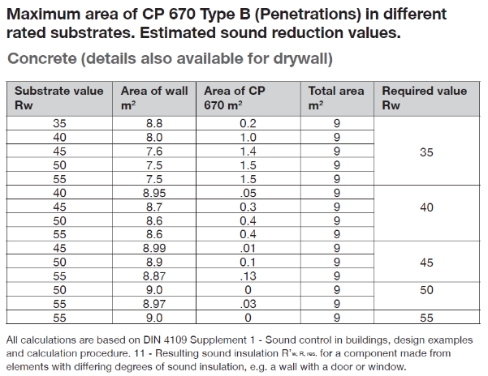
5.5 |  | INSTALLATION
 |  | .1 |  |  | Floor and Wall Openings
 |  |  |  |  | i |  |  |  | Clean the opening. Do not pre-moisten opening surfaces. Cables and cables supporting structures must be dry and clean from dust, grease or oil, and installed in compliance with local building codes and standards.
 |  |  |  |  | ii  iii  iv  v |  |  |  | Cut the mineral wool to size. In case of services cut out required space. Coat cut edges with Hilti CP 606 Firestop Sealant.  Coat the surface of the opening with Hilti CP 606 Firestop Sealant (refer to relevant BS reports for specific details). Insert the mineral wool panel flush with the opening edge.  Pack any larger gaps with loose mineral wool. Seal between cables with Hilti CP 606 Firestop Sealant.  Thoroughly stir CP 670 Firestop Coating. Apply CP 670 Firestop Coating to the cables and cable trays on all surfaces over the required length. It can be applied using a brush, roller or airless spray gun (recommendation: a nozzle 0.029” diameter, spray angle 40°). To achieve the dry coating of 0.7 mm, a wet film thickness of 1.1 mm is required. Fasten installation plate (if required)
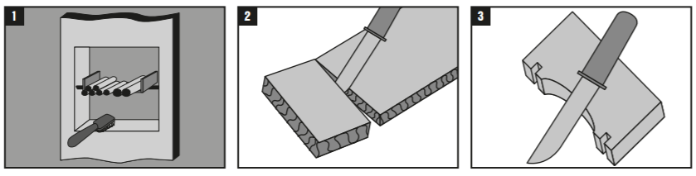
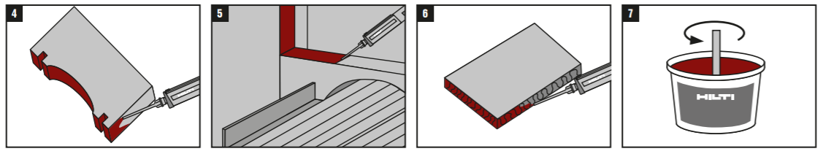
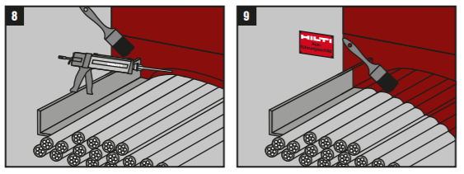

5.6 | SUBMISSIONS
 | .1 | Information Required in Tender Return  If The Tenderer is submitting other Proprietory Made For the Architect’s Consideration As Approved Equivalent:-  The Tenderer shall provide the following information for the Hilti Fire Protection Systems equivalent proposal within their tender submission.
 |  | i |  | Statement of compliance with the fire specification
 |  | ii |  | Data sheets of the proposed fire rated seal for the fire rated partitions.
 |  | iii |  | Acoustic and fire rated test reports for the proposed fire rated seal tests performed at an accredited and independent test laboratory.
 |  | iv |  | Current Jabatan Bomba dan Penyelamat Malaysia Fire Certificate.
 |  | v |  | Local Commercial Project Reference.
 | .2 | Information Required in Post Tender  After award of the contract, the Main Contractor and the passive fire protection system contractor shall submit the following information for approval by the Architect:
 |  | i |  | Detailed shop drawings
 |  | ii |  | A detailed construction and installation program
 |  | iii |  | Confirmation of compliance to the original specification prior to commencement on site.
 |  | iv |  | Construction method statement
 |  | v |  | Commissioning test report showing compliance with the performance specification.
 |  | vi |  | C1, C2 and C3 documentation for submission to Jabatan Bomba dan Penyelamat Malaysia
6.0 | CP 643 N / 644 Firestop Collars
 | TECHNICAL SPECIFICATIONS
6.1 | DESCRIPTION
 | CP 643 N / 644 Firestop Collars is an UL-compliant and FM-approved retrofit firestop collar with a galvanized steel housing to help create a fire and smoke barrier around existing pipe penetrations.
 | .1 | Contact Details  Hilti (Malaysia) Sdn Bhd  F-5-A, Sime Darby Brunsfield Tower  No. 2, Jalan PJU 1A/7A, Oasis Square, Oasis Damansara  47301 Petaling Jaya  Selangor Darul Ehsan  Malaysia  Tel No: 1800 – 880 - 985  Fax No. +603 – 7848 7399  E-mail: myhilti@hilti.com
6.2 | APPLICATION  As part of the comprehensive Hilti Firestop Protection system, CP 643 N / CP 644 Firestop Collars is use for sealing flammable pipes from 32 mm to 250 mm in diameter in penetrations through fire compartment walls and floors and it has flexible hook positioning for convenient fastening.
6.3 | FIRE TEST PERFORMANCE
 | .1 | Standards  All materials and installation shall be executed in accordance with the latest British Standards, European Standards, UL Listings and Malaysian Building Codes and codes of practice, in particular:
 |  | i | BS 476 Part 20: 1987 Fire test on building materials and structures
 |  | ii | MS 1183: 2015, “Fire Safety in The Design, Management and Use of buildings - Code of Practice”
 |  | iii | UL 1479, “Fire Tests of Through Penetration Firestops”
 |  | iv  v  vi  vii | ASTM E 814, "Standard Method of Fire Tests of Through Penetration Firestops"  EN 1366 Part 3: 1998 Penetration seals  ASTM E 2174, “Standard Practice for On-site Inspection of Installed Firestops”  International Firestop Council Guidelines for Evaluating Firestop Systems Engineering Judgments.
 | .2 | Suitable Testing Authorities
 |  | i | Interlek (Omega Point) Listings
 |  | ii | Omega Point Laboratories
 |  | iii | Underwriters Laboratories Inc. (UL)
 |  | iv | Exova Warrington fire
 |  | v  vi  vii | Factory Mutual Standards Laboratories (FM)  Warnock Hersey  Société Générale de Surveillance (SGS)
The CP 643 N / CP644 Firestop Collars provide up to 4 hours fire rating, when tested at an accredited and independent test laboratory in accordance with the table below:

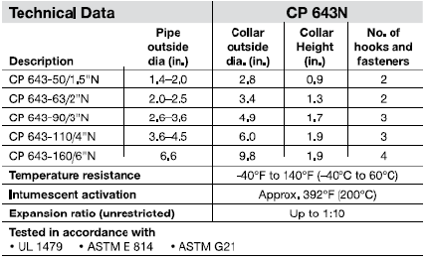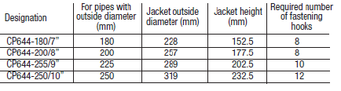

6.4 | INSTALLATION
.1 Clean the combustible pipe
Expansion of the intumescent material during a fire acts to close the combustible pipe. Very dirty pipes with, for example, remains of mortar, may lead to a delay in this closing action. Badly soiled plastic pipes should, therefore, be cleaned in the area where the CP 643 N / 644 firestop collar is to be installed.

.2 Application of firestop system
Seal the opening. Gaps must be closed with FS-ONE MAX. The approved methods vary and are given in the specific U.L. Systems.

.3 Close the CP 643 N / 644 Firestop Collar
Place the CP 643 N / CP644 firestop collar around the combustible pipe and lock the closure by applying firm pressure until it latches.

.4 Attach fastening hooks.
The fastening hooks can be attached to various points on the metal housing. This allows the fastening points to be made to suit the space available in each case. The hooks must be positioned as symmetrically as possible. The required number of fastening hooks is indicated on the packaging.

.5 Fastening the CP 643 N / 644 firestop collar.
Only when fastened properly can firestop collar offer protection against fire passing through.
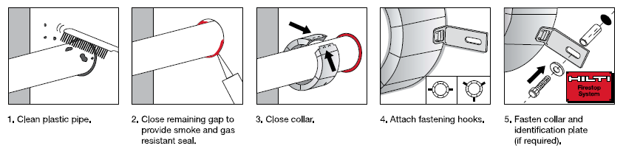

 | Under fire conditions, the intumescent material expands against the structure and fills the void left by the burnt out plastic.
6.5 | SUBMISSIONS
 | .1 | Information Required in Tender Return  If The Tenderer is submitting other Proprietary Made For the Architect’s Consideration As Approved Equivalent:-  The Tenderer shall provide the following information for the Hilti Fire Protection System equivalent proposal within their tender submission.
 |  | i | Statement of compliance with the fire specification
 |  | ii | Data sheets of the proposed fire rated seal for the fire rated partitions.
 |  | iii | Fire rated test reports for the proposed fire rated seal tests performed at an accredited an independent test laboratory as shown above.
 |  | iv | Current Jabatan Bomba dan Penyelamat Malaysia Fire Certificate.
 |  | v | Local Commercial Project Reference.
 | .2 | Information Required in Post Tender  After award of the contract, the Main Contractor and the passive fire protection system contractor shall submit the following information for approval by the Architect:
 |  | i | Detailed shop drawings
 |  | ii | A detailed construction and installation program
 |  | iii | Confirmation of compliance to the original specification prior to commencement on site.
 |  | iv | Construction method statement
 |  | v | Commissioning test report showing compliance with the performance specification.
 |  | vi | C1, C2 and C3 documentation for submission to Jabatan Bomba dan Penyelamat Malaysia
7.0 | CP 680-P Cast-In Firestop Devices
 | TECHNICAL SPECIFICATIONS
7.1 | DESCRIPTION
 | CP 680-P Cast-In Firestop Devices is a one-step cast-in firestop device for a variety of pipe materials and diameters for penetration through floors. Place it and forget it.
 | .1 | Contact Details  Hilti (Malaysia) Sdn Bhd  F-5-A, Sime Darby Brunsfield Tower  No. 2, Jalan PJU 1A/7A, Oasis Square, Oasis Damansara  47301 Petaling Jaya  Selangor Darul Ehsan  Malaysia  Tel No: 1800 – 880 - 985  Fax No. +603 – 7848 7399  E-mail: myhilti@hilti.com
7.2 | APPLICATION  As part of the comprehensive Hilti Firestop Protection system, CP 680-P Cast-In Firestop Device is use for effectively sealing most common through penetrations in a variety of base materials – including concrete slabs built with traditional formwork or metal decking.  In addition, it brings peace of mind – cast-in devices remove scope for errors compared to traditional methods, leading to more reliable firestopping of vertical penetrations.
7.3 | FIRE TEST PERFORMANCE
 | .1 | Standards  All materials and installation shall be executed in accordance with the latest British Standards, European Standards and Malaysian Building Codes and codes of practice, in particular:
 |  | i | BS 476 Part 20: 1987 Fire test on building materials and structures
 |  | ii | MS 1183: 2015, “Fire Safety in The Design, Management and Use of buildings - Code of Practice”
 |  | iii | UL 1479, “Fire Tests of Through Penetration Firestops”
 |  | iv  v  vi  vii | ASTM E 814, "Standard Method of Fire Tests of Through Penetration Firestops"  EN 1366 Part 3: 1998 Penetration seals  ASTM E 2174, “Standard Practice for On-site Inspection of Installed Firestops”  International Firestop Council Guidelines for Evaluating Firestop Systems Engineering Judgments.
 | .2 | Suitable Testing Authorities
 |  | i | Interlek (Omega Point) Listings
 |  | ii | Omega Point Laboratories
 |  | iii | Underwriters Laboratories Inc. (UL)
 |  | iv | Exova Warrington fire
 |  | v  vi  vii | Factory Mutual Standards Laboratories (FM)  Warnock Hersey  Société Générale de Surveillance (SGS)

7.4 | SMOKE SEAL  CP 680-P Cast-In Firestop Devices shall provide a smoke seal.
7.5 | LOW VOC PERFORMANCE  The purpose of this test is to show that specific Hilti Firestop products are low VOC compliant. The emissions of volatile organic compounds are tested by drawing sample air from the test chamber outlet through Tenax TA tubes after the specified duration of storage in the ventilated test chamber. Analysis is performed by ATD-GC/MS using HP-5 column (30 m, 0.25mm ID, 0.25μm film).  The test result shows Hilti CP 680-P Cast-In Firestop Devices passed the low-VOC test.  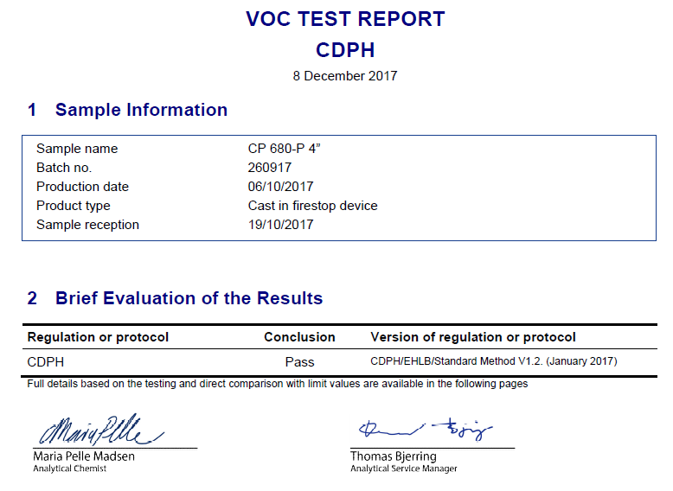

7.6 | INSTALLATION  .1 Clean the surfaces. Surfaces to which CP 680-P will be applied should be cleaned of loose debris, dirt, oil, moisture, frost and wax. Structures supporting penetrating items must be installed in compliance with local building and electrical standards.  .2 Do the marking on the formwork for the appropriate location for the CP 680-P Cast-In Firestop Devices to be installed.  .3 Place and aligning the CP 680-P Cast-In Firestop Devices into the designated spot on the formwork then install and secured it to the formwork by fixing nails. Before pouring of concrete, secure the cover cap in place, thereby preventing the flow of concrete into the cast-in devices.  .4 Remove the cover cap of CP 680-P Cast-In Firestop Devices after concrete curing and place the penetrants for successful passive firestopping performance.  .5 For maintenance reasons, a penetration seal could be permanently marked with an identification plate/sticker. In such a case, mark the identification plate/sticker and fasten it in a visible position next to the seal.  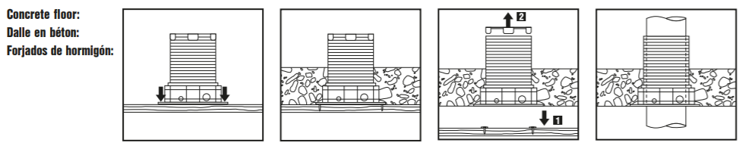
7.7 | SUBMISSIONS
 | .1 | Information Required in Tender Return  If The Tenderer is submitting other Proprietary Made For the Architect’s Consideration As Approved Equivalent:-  The Tenderer shall provide the following information within the tender submission:-
 |  | i | Statement of compliance with the fire specification
 |  | ii | Data sheets of the proposed fire rated seal for the fire compartmentation.
 |  | iii | Acoustic, water tightness and fire rated test reports for the proposed fire rated sealant tests performed at an accredited an independent test laboratory.
 |  | iv | Current Jabatan Bomba dan Penyelamat Malaysia Fire Certificate.
 |  | v | Local Commercial Project Reference.
 | .2 | Information Required in Post Tender  After award of the contract, the passive fire protection system contractor shall submit the following information for approval by the Architect:
 |  | i | Detailed shop drawings
 |  | ii | A detailed construction and installation program
 |  | ii | Confirmation of compliance to the original specification prior to commencement on site.
 |  | iii | Construction method statement
 |  | iv | Commissioning test report showing compliance with the performance specification.
 |  | v | C1, C2 and C3 documentation for submission to Jabatan Bomba dan Penyelamat Malaysia
 |  |  | END OF SECTION

